Step 1:

第三方机器或者本地机器

Create Certificate in Power shell

$cert = New-SelfSignedCertificate -DnsName "CN=PreactorIntegrationTest2,T=SimaticIT UA Foundation" -CertStoreLocation "cert:\LocalMachine\My"-KeyExportPolicy Exportable -KeySpec Signature

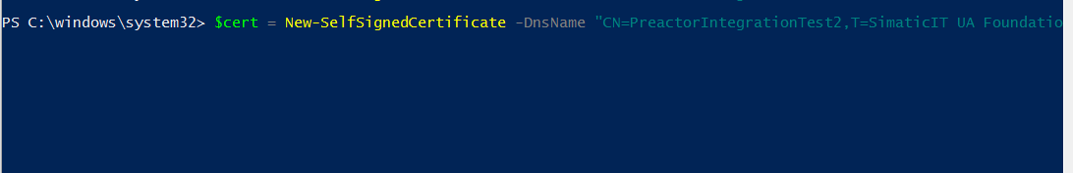

Execute without any error



红色名字部分，可以自定义

Step 2

第三方机器或者本地机器

One MMC (Run –MMC)

File Add/Remove Snap in

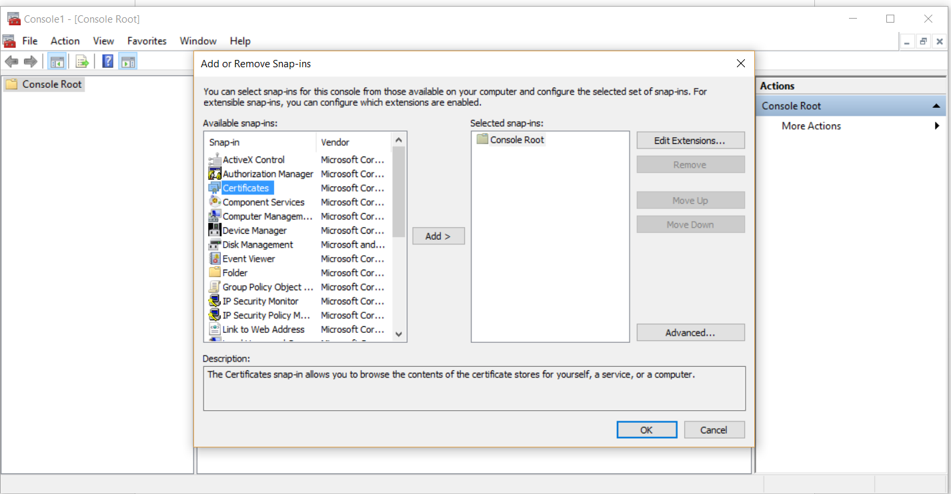

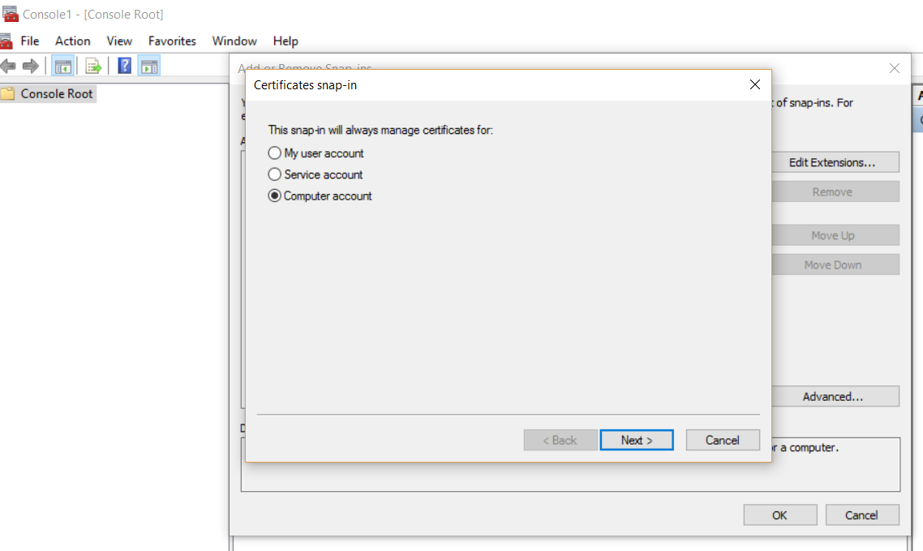

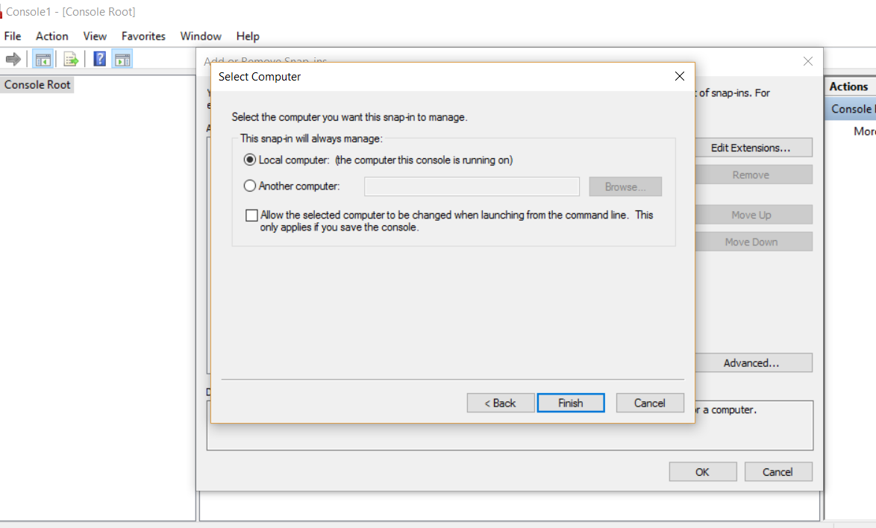

Click ok

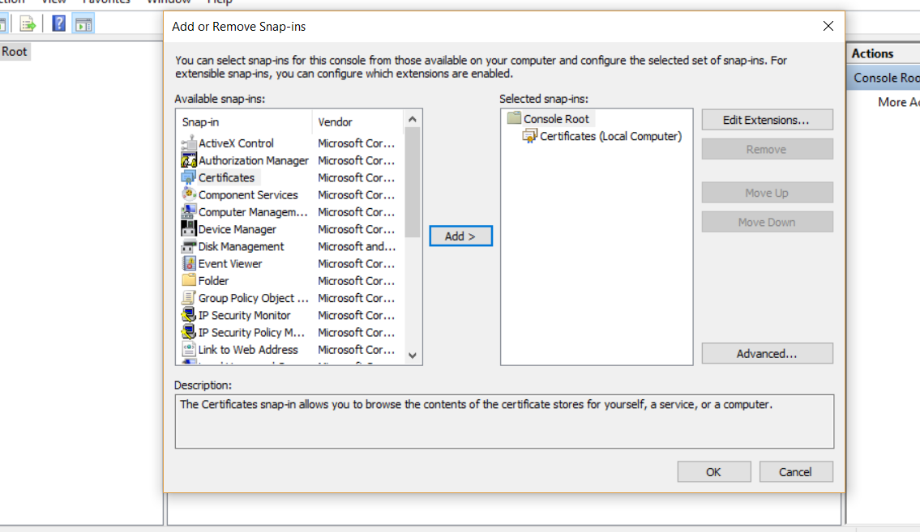

View Certificate

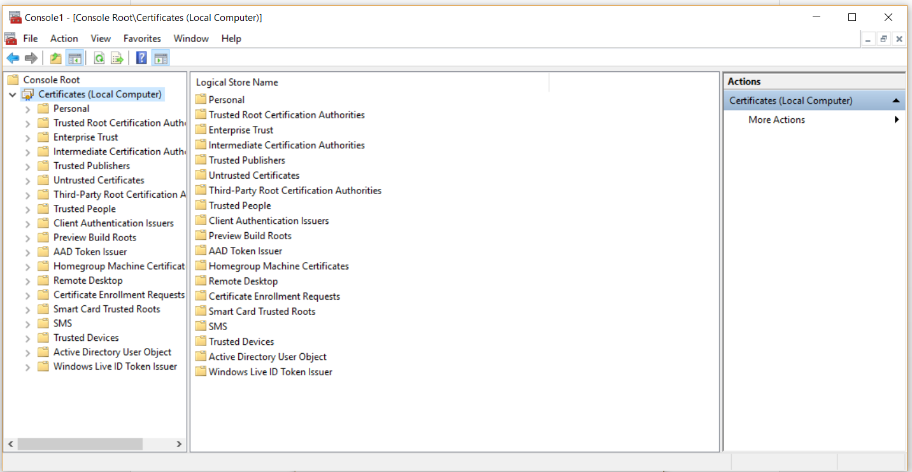

Locate the certificate created under Intermediate Certificate Authorities

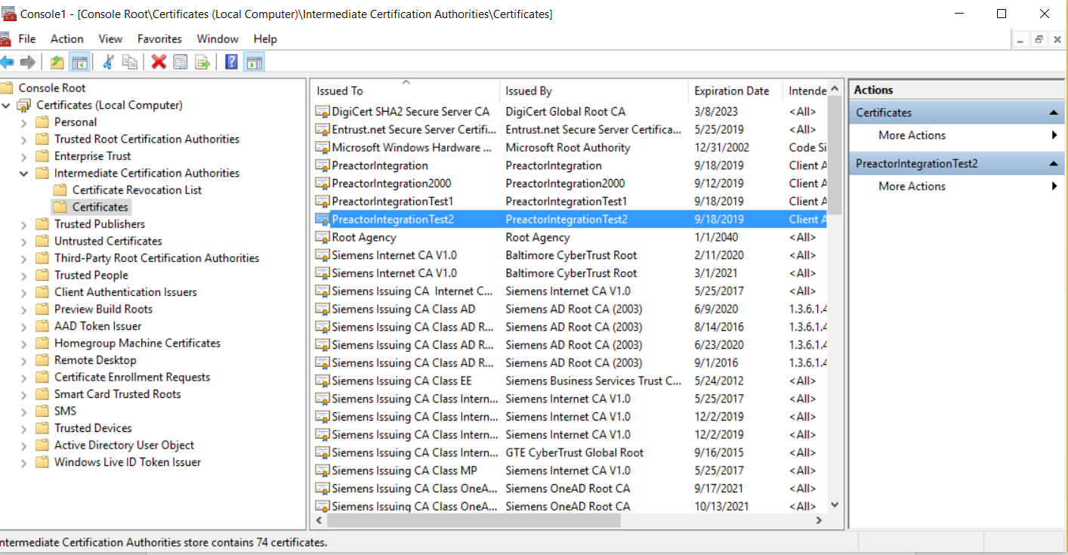

Step 2 : Export certificate as .CER file

On Preactor Machine open MMC and locate certificate as shown in previous step , right click on the certificate and export

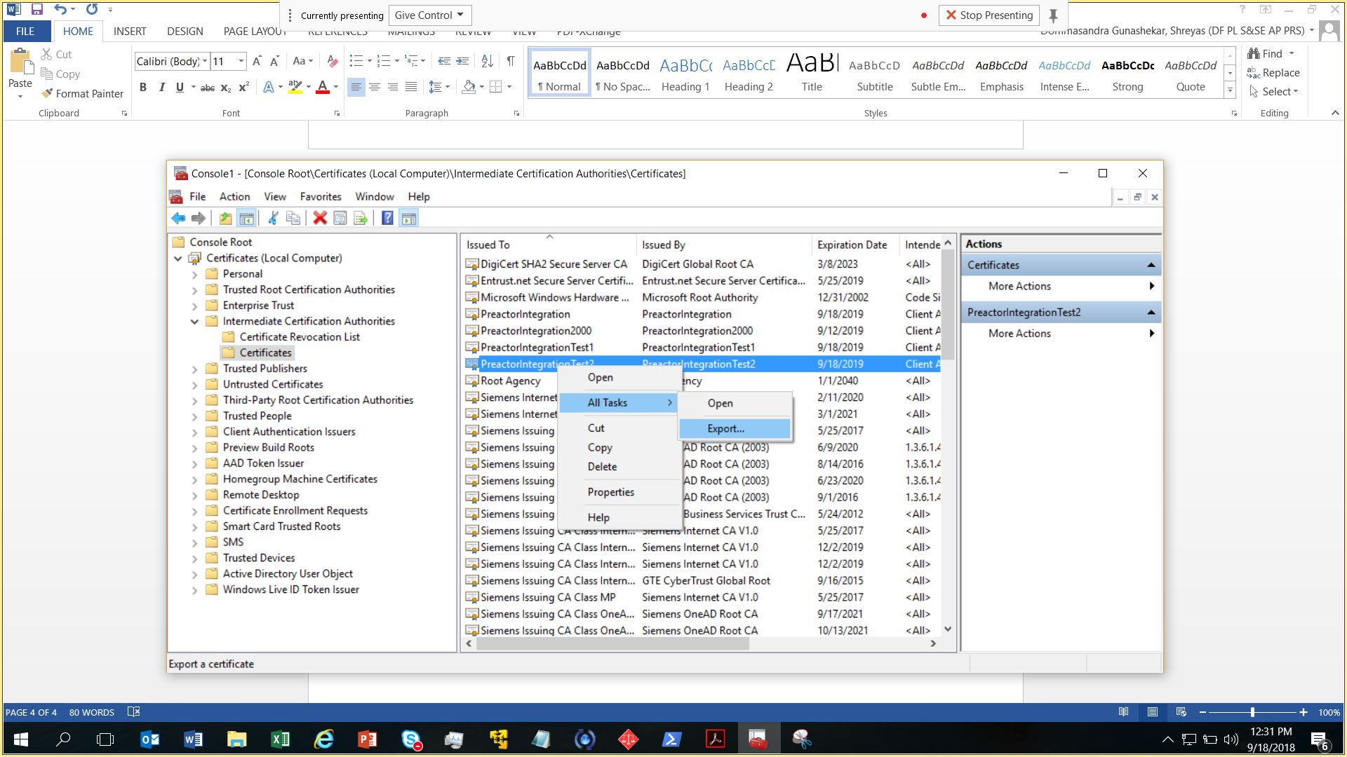

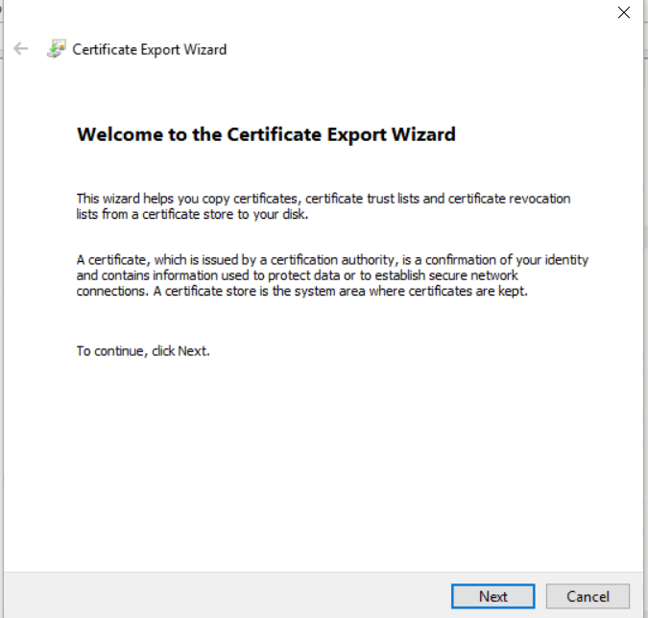

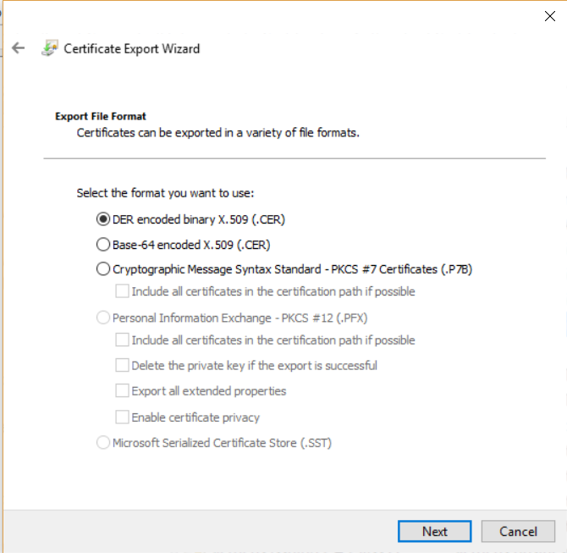

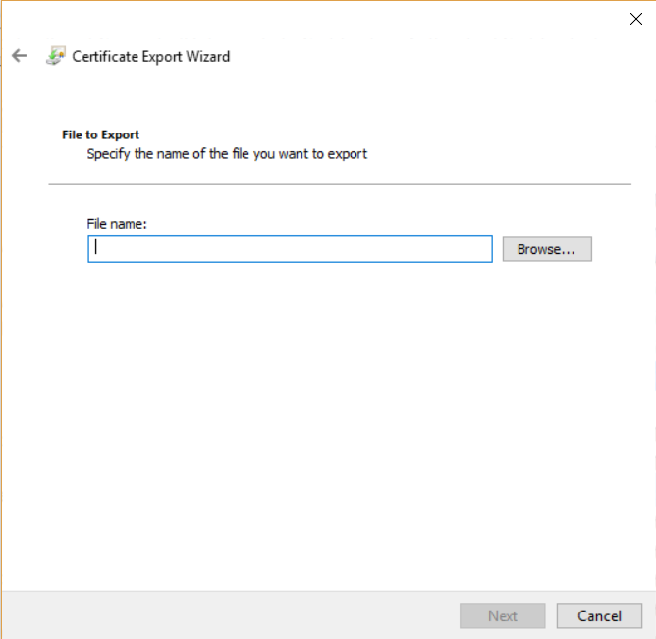

Browse the path and specify the file name

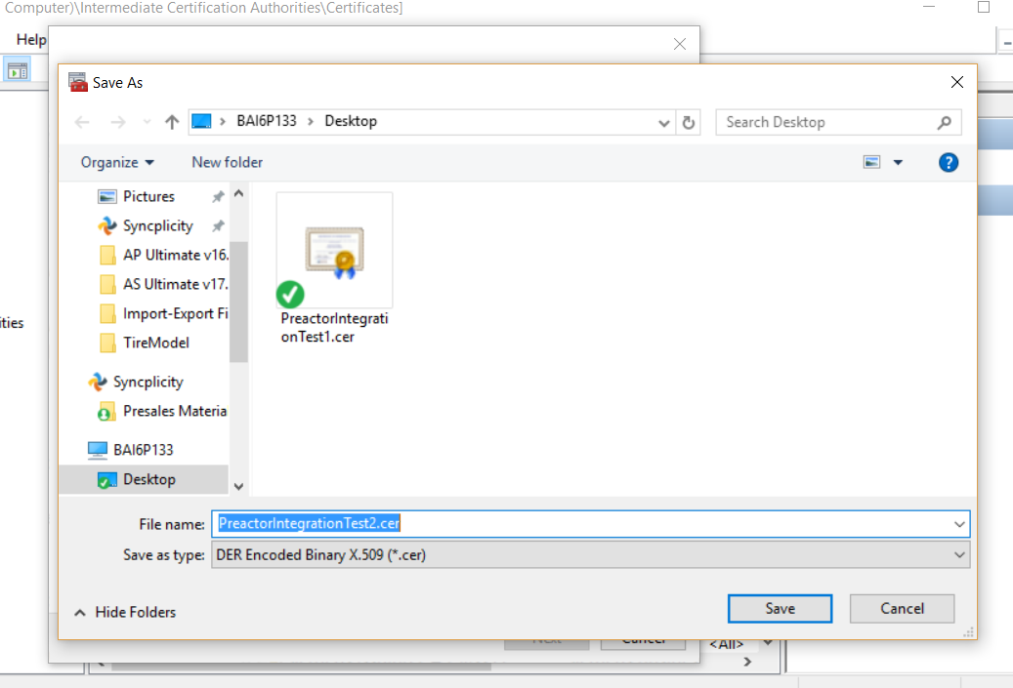

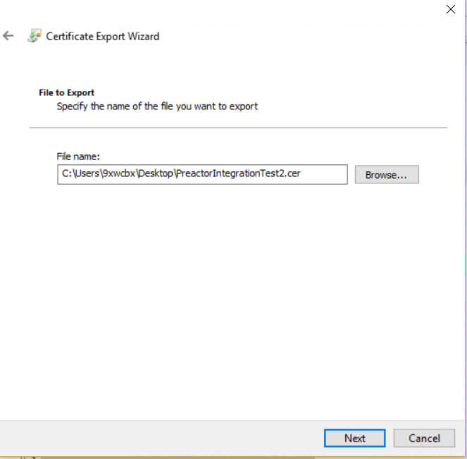

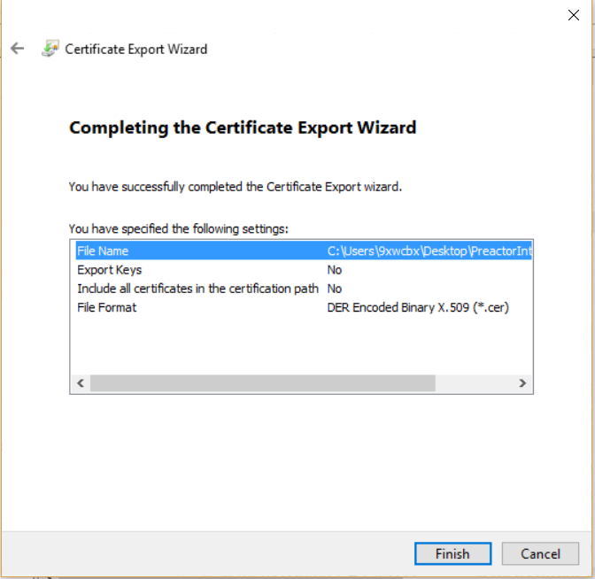

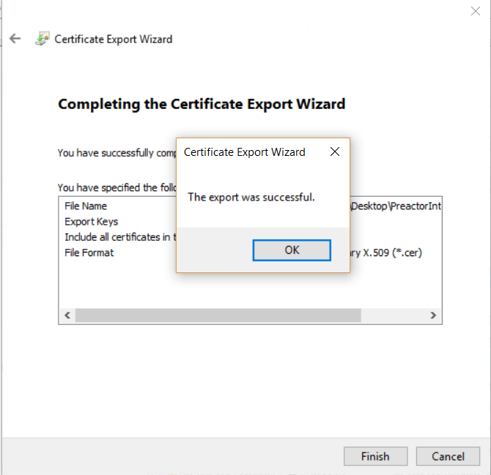

Step 3 : Install certificate on Preactor Application Machine

Locate the .CER file created and double click on it

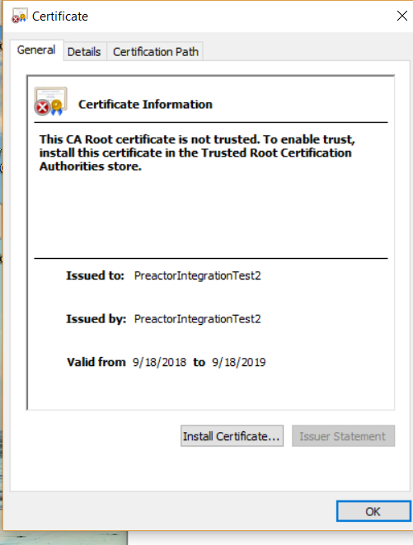

Click on Install Certificate

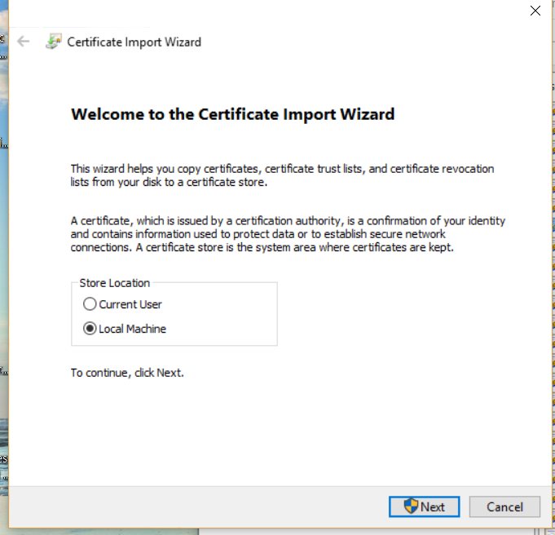

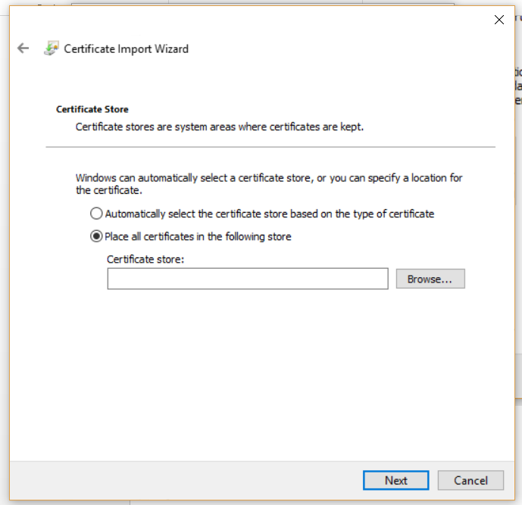

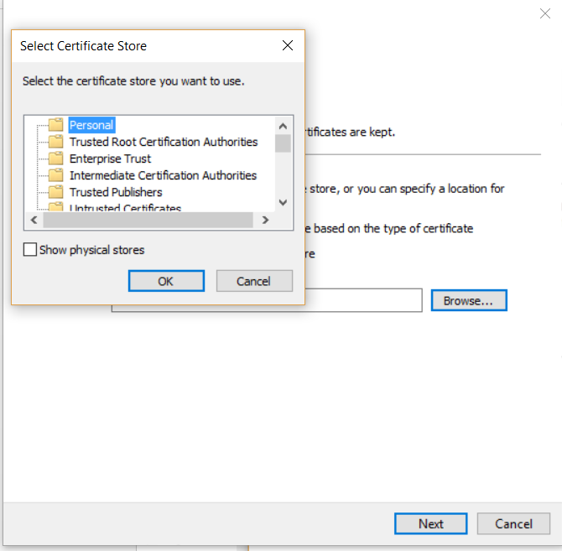

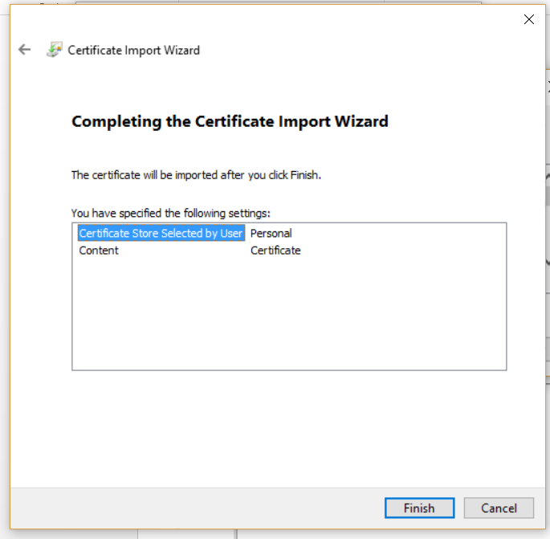

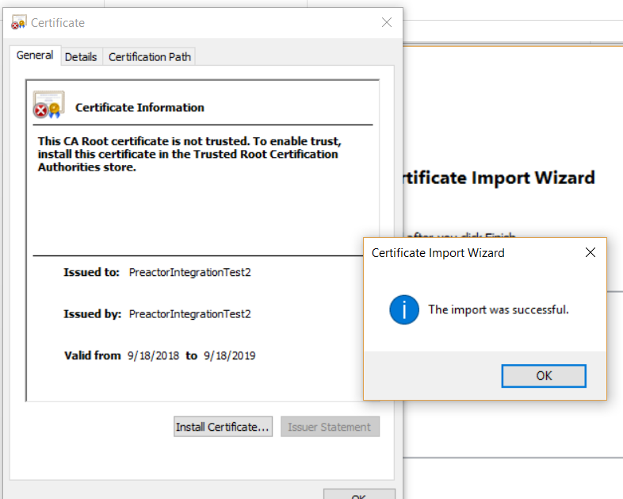

Step 4 : Install certificate in UADM server Machine from the .CER File

Copy the .CER file generated on 第三方机器或者Studio机器上in the previous step and paste in UADM server machine

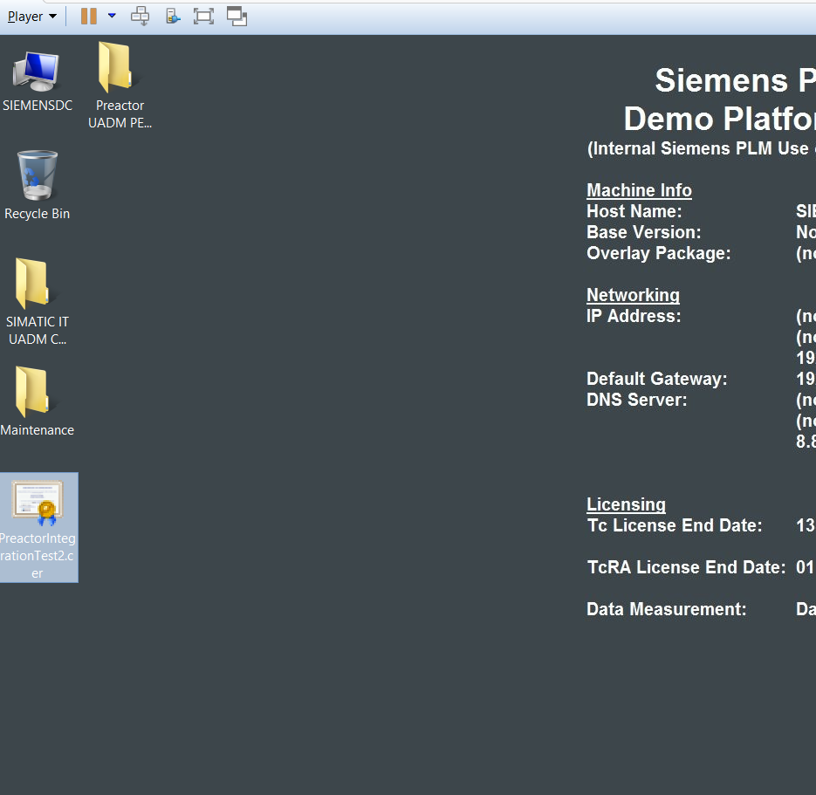

Double click on the .CER file

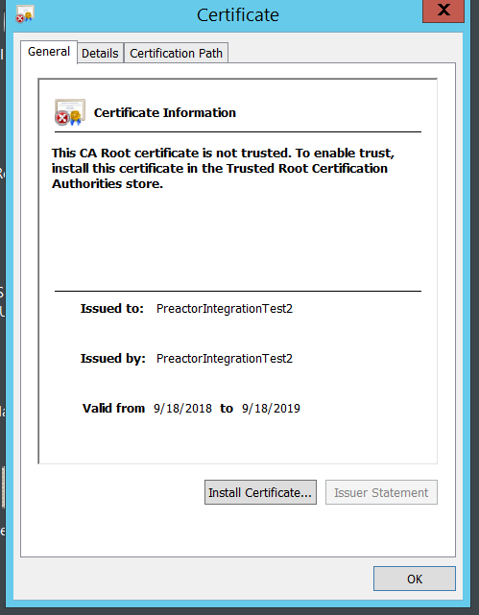

Click on Install certificate

